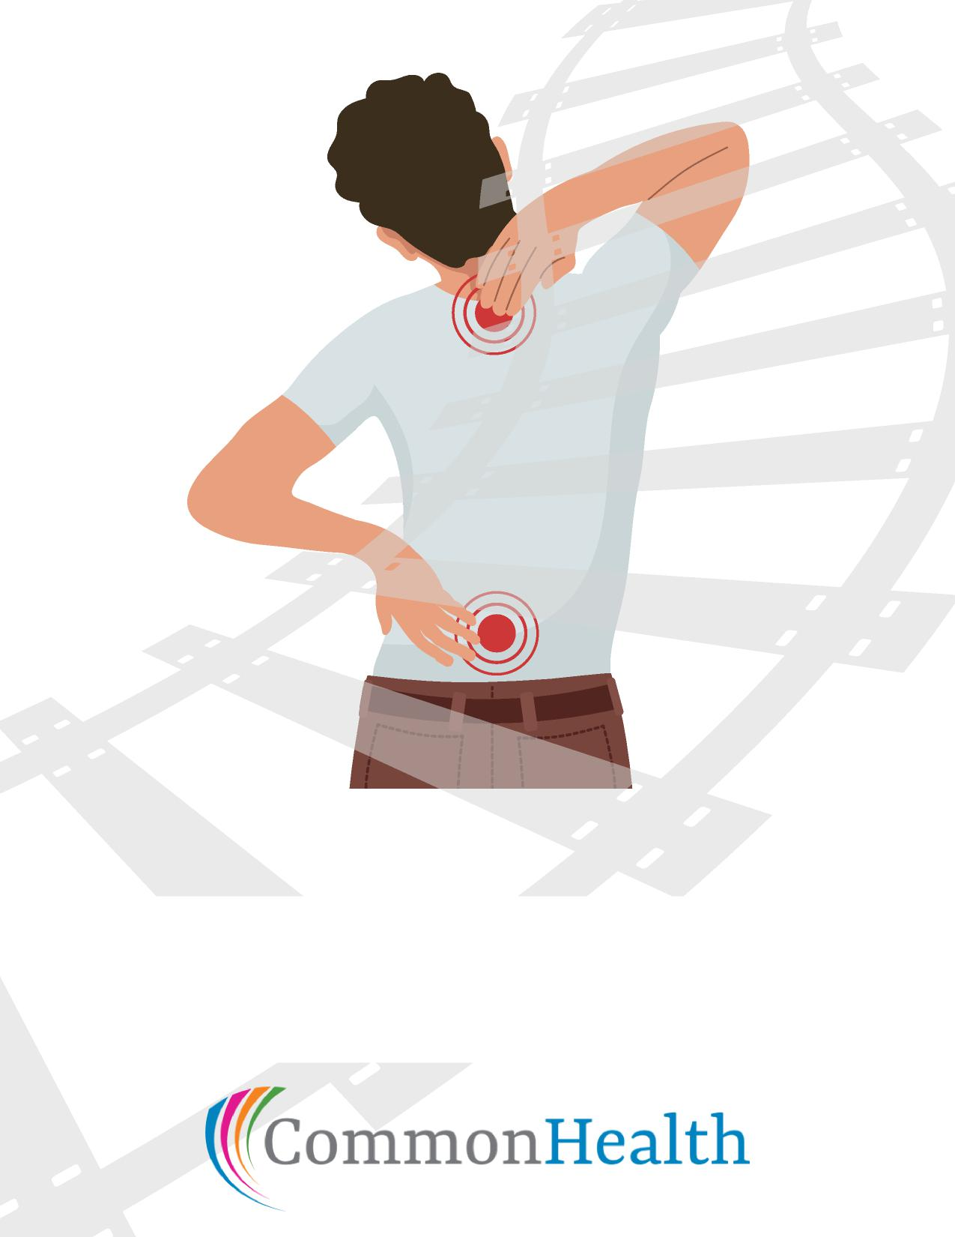

**Back on Track**

**A Guide to a Healthy Back**

**Join Us**

**When:**

**Where:**