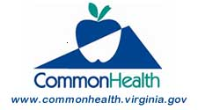
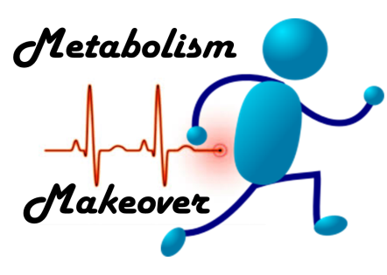
Metabolism
Makeover

Before diving into ways to boost your metabolism, it is important to understand what exactly metabolism is. Metabolism is the rate at which your body processes the food you eat. Increasing your metabolic rate leads to weight loss without cutting important calories. Here are a few simple steps to help boost your metabolic rate.

Eating Small and Frequent Meals – Eating more often can help you boost your metabolism and lose weight. When you eat large meals with many hours in between, your metabolism slows down between the meals. Having a small meal or healthy snack every 3-4 hours keeps your metabolism humming so you burn more calories throughout the day.

Aerobic Exercise - A healthy diet and exercise go hand in hand with losing weight and increasing metabolism. It is important to have at least 30 minutes of exercise every day. Exercise increases metabolic rate while you are moving and for up to a few hours after you finish. If time is short, try intervals of 5-15 minutes of more vigorous activity.

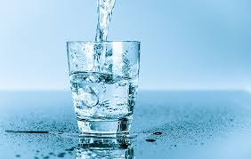
Water – Your body needs water to process calories. If you are even mildly dehydrated, your metabolism may slow down. In one study, adults who drank at least 8 glasses of water a day burned more calories than those who drank 4 glasses. To stay well hydrated, drink a glass of water or another unsweetened beverage before every meal and snack.

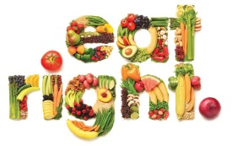
Follow a Healthy Diet – Fad diets don’t work. These dramatically restrict your calories (<1,200 calories per day), which has a negative effect on your metabolism. The most damaging part of these diets is that the initial weight loss will slow your metabolism (because you lose muscle), leading to later weight gain. Additionally, because of restrictions they place on types of foods (carbs, fat, etc.), they may lead to nutritional deficiencies. Instead, focus on making a healthy lifestyle change. Add more nutrient dense vegetables and fruit to your meals. Skip the fat-filled sauces and dressings whenever you can. Swap sugar sweetened beverages for water. Little changes like these can make a huge difference.

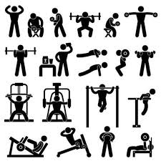
Strength Training – Building muscle through weight training boosts your metabolic rate. Muscle burns more calories than fat so the more muscle you have, the higher your metabolic rate will be. The best part about weight training is that every ounce of muscle you gain burns more calories… even when you are sleeping or at rest. If lifting weights or using machines at the gym isn’t your style, try using your body weight as resistance. Exercises like chair squats and wall pushups build muscle, too!

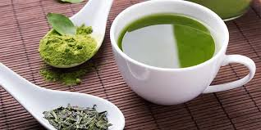
Green Tea - Combining green tea with a healthy diet and regular exercise is a simple way to boost your metabolism. Green tea leaves contain a plant compound called ECGC that promotes fat metabolism. While the verdict is still out on exactly how much green tea to drink to lose weight, you may want to at least get started with a cup or two. Research suggests that drinking 2+ cups of green tea per day may push the body to burn 17% more calories during exercise.

Visit www.commonhealth.virginia.gov for more great information.

