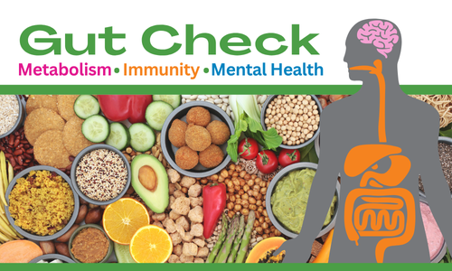
If you’ve been hearing a lot about Gut Health lately and wondered what it means, then you are in luck!
Join CommonHealth to learn why Gut Health is crucial for overall wellbeing and how it plays an important role in digestion, immune function, nutrient absorption, and even mental health.

ENTER DATE | ENTER TIME
ENTER LOCATION

commonhealth.virginia.gov

