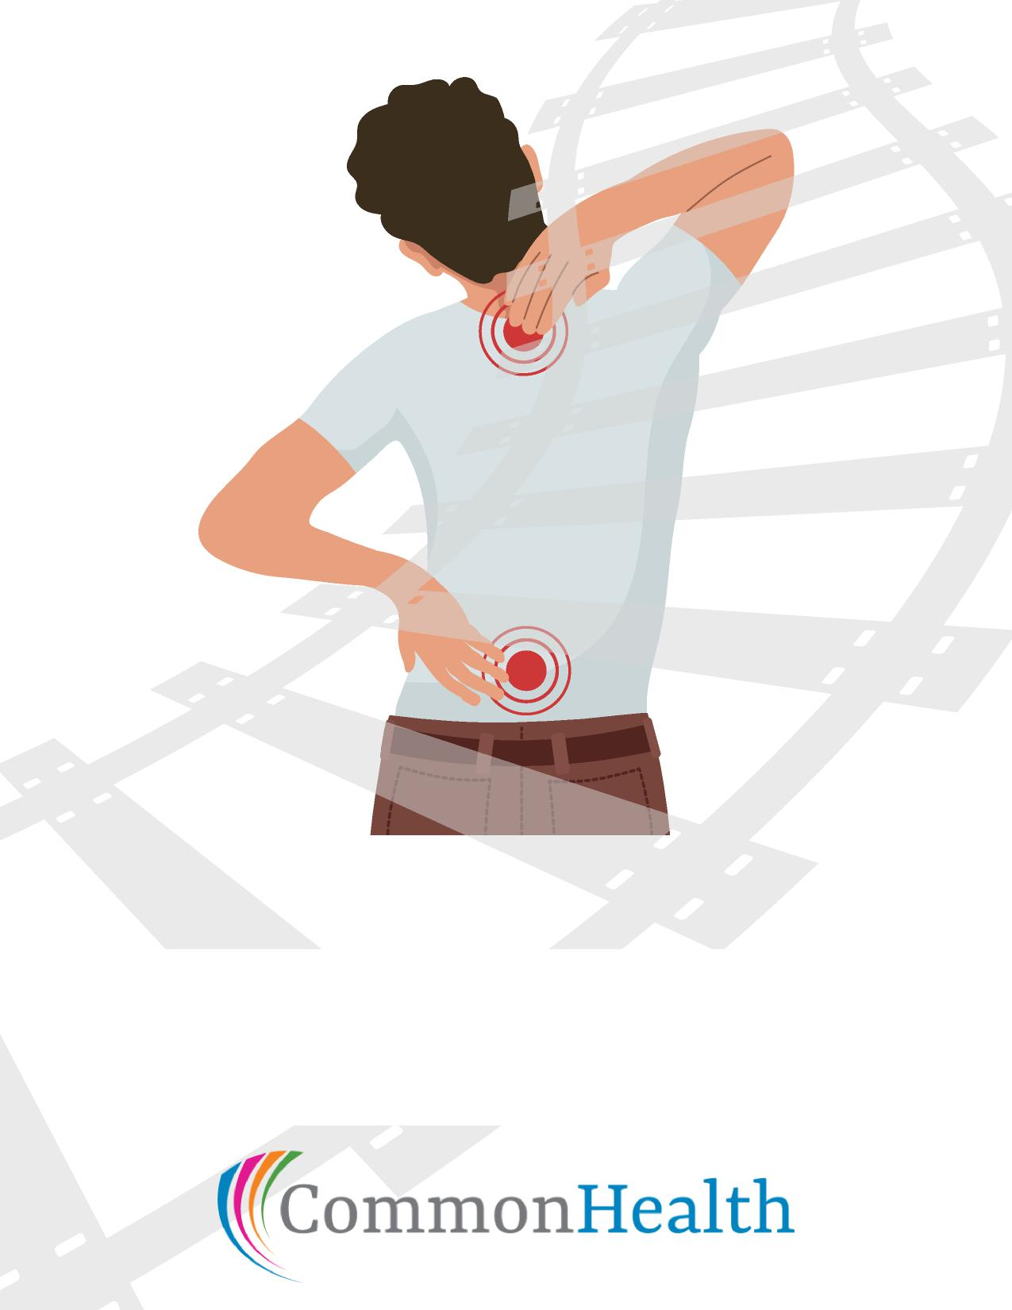
Back on Track
A Guide to a Healthy Back
Join Us
When:
Where:

